

*IdentityIQ Accelerator Pack Mine Provisioning Policies*

Table of Contents

1. Overview 3

2. Mining Process 3

3. Mined Provisioning Polices 4

**Document Revision History**

|  |  |  |  |  |
| --- | --- | --- | --- | --- |
| **Version** | **Date** | **Status** | **Author** | **Summary of Changes** |
| Version 1 | 3/2/18 |  | Rohit Gupta |  |
| Version 2 | 4/4/18 |  | Cathy Mallet | Minor grammar/spelling/etc edit |

## Overview

The Mine Provisioning Policies feature compares baseline Identities from authoritative sources and baseline accounts from applications to auto-generate BeanShell provisioning rules for new account creation.

Also, it generates rules for disable, enable, update, unlock, and change password policies based on the selected fields on the mining form.

## Mining Process

This process starts from a “Mine Provisioning Policies” QuickLink.

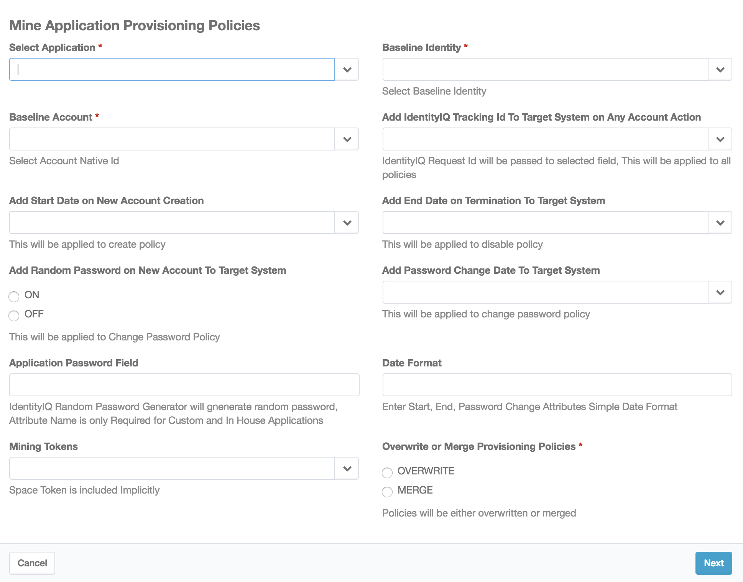

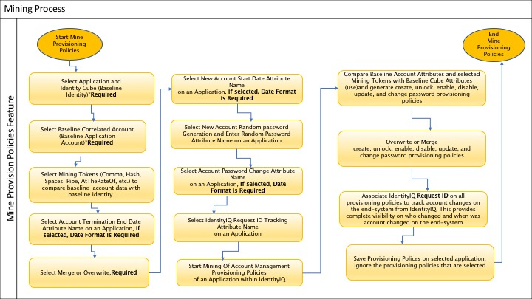

## Mined Provisioning Polices

The mining tool will auto-generate forms, sections, fields, and rules, per application. Provisioning Policies will be merged or overwritten based on mining form selections. On the the mining results form, the provisioning policy per application schema field can be ignored, if selected. Please see the screen shot below.

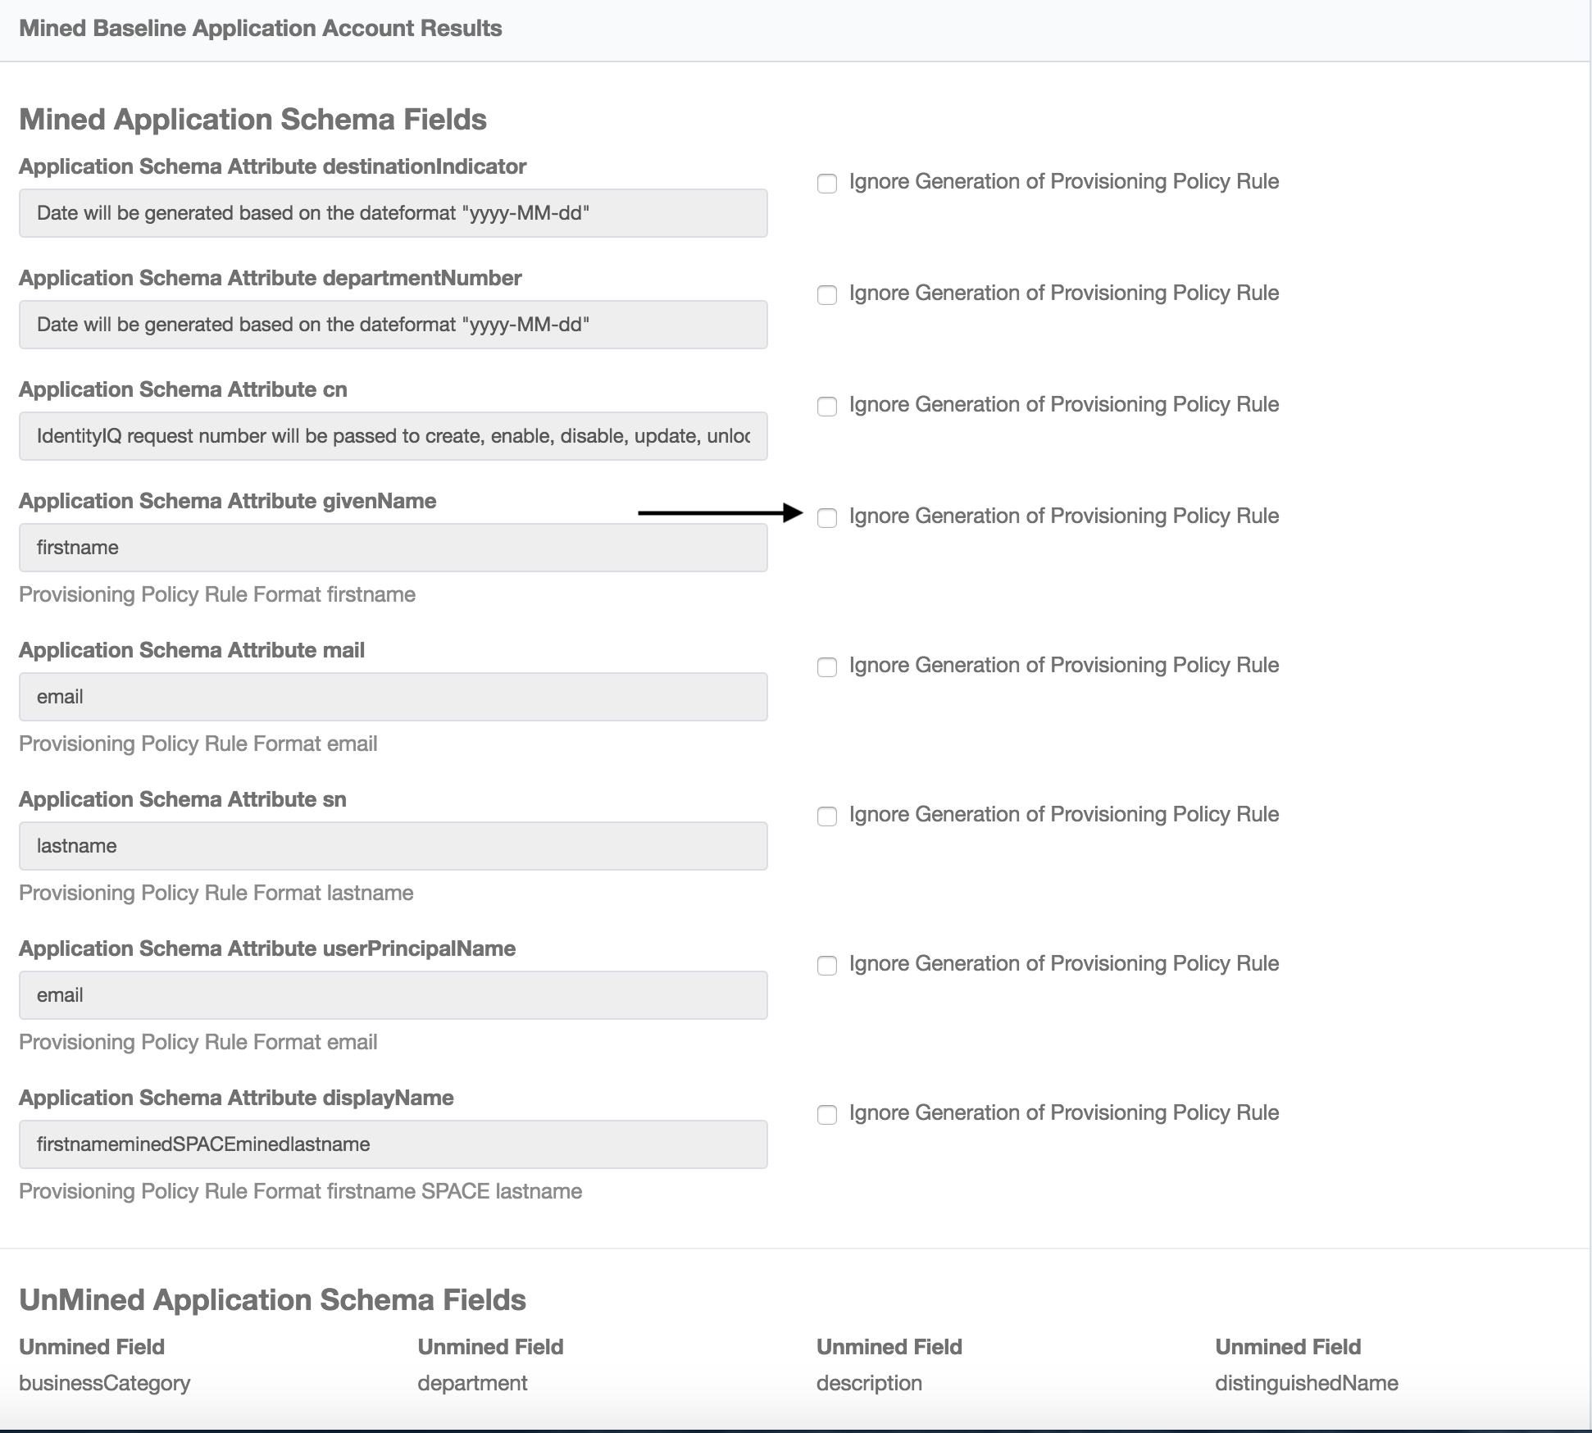

**Naming convention**

Auto-generated Provisioning Polices will use the following naming conventions for form, section, field, and rules.

* Mined Create [Application Name<Removed Special Characters>] Form
  + Mined Create [Application Name<Removed Special Characters>] Section
    - Mined Create [Application Name<Removed Special Characters>][ Mined Application Schema Field Name..]
      * Rule-Mined-Create-[Application Name<Removed Special Characters>]-[Mined Application Schema Field Name..]
    - Mined Create [Application Name<Removed Special Characters>] IdentityIQ Tracking Id Field
      * Rule-Mined-All-Policy-[Application Name<Removed Special Characters>]-[Application Schema IdentityIQ Tracking Id Field Field Name]
    - Mined Create [Application Name<Removed Special Characters>] Start Date Field
      * Rule-Mined-Create-[Application Name<Removed Special Characters>]-[Application Schema Start Date Field Name]
    - Mined Create [Application Name<Removed Special Characters>] Password Field
      * Rule-Mined-Create-[Application Name<Removed Special Characters>]-[Application Password Field Name]
* Mined Disable [Application Name<Removed Special Characters>] Form
  + Mined Disable [Application Name<Removed Special Characters>] Section
    - Mined Disable [Application Name<Removed Special Characters>] IdentityIQ Tracking Id Field
      * Rule-Mined-All-Policy-[Application Name<Removed Special Characters>]-[Application Schema IdentityIQ Tracking Id Field Field Name]
    - Mined Disable [Application Name<Removed Special Characters>] End Date Field
      * Rule-Mined-Disable-[Application Name<Removed Special Characters>]-[Application Schema End Date Field Name]
* Mined Enable [Application Name<Removed Special Characters>] Form
  + Mined Enable [Application Name<Removed Special Characters>] Section
    - Mined Enable [Application Name<Removed Special Characters>] IdentityIQ Tracking Id Field
      * Rule-Mined-All-Policy-[Application Name<Removed Special Characters>]-[Application Schema IdentityIQ Tracking Id Field Field Name]
* Mined Unlock [Application Name<Removed Special Characters>] Form
  + Mined Unlock [Application Name<Removed Special Characters>] Section
    - Mined Unlock [Application Name<Removed Special Characters>] IdentityIQ Tracking Id Field
      * Rule-Mined-All-Policy-[Application Name<Removed Special Characters>]-[Application Schema IdentityIQ Tracking Id Field Field Name]
* Mined Update [Application Name<Removed Special Characters>] Form
  + Mined Update [Application Name<Removed Special Characters>] Section
    - Mined Update [Application Name<Removed Special Characters>] IdentityIQ Tracking Id Field
      * Rule-Mined-All-Policy-[Application Name<Removed Special Characters>]-[Application Schema IdentityIQ Tracking Id Field Field Name]
* Mined Change Password [Application Name<Removed Special Characters>] Form
  + Mined Change Password [Application Name<Removed Special Characters>] Section
    - Mined Change Password [Application Name<Removed Special Characters>] IdentityIQ Tracking Id Field
      * Rule-Mined-All-Policy-[Application Name<Removed Special Characters>]-[Application Schema IdentityIQ Tracking Id Field Field Name]
    - Mined Change Password [Application Name<Removed Special Characters>] Password Change Date Field
      * Rule-Mined-Change-Password--[Application Name<Removed Special Characters>]-[Application Schema Password Change Date Field Field Name]